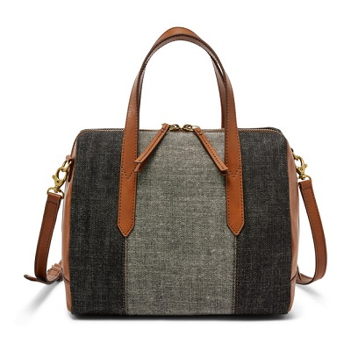

RYDER MINI SATCHEL

PRODUCT DETAILS

**Silhouette:** Mini Satchel

**Tech Compatibility:** iPhone® 6 Plus, iPhone® 7 Plus, iPhone® 8 Plus

**Exterior Material:** Leather

**Interior Details:** 1 Slide Pocket, 1 Zipper Pocket

**Measurements:** 9"L x 4.25"W x 7"H